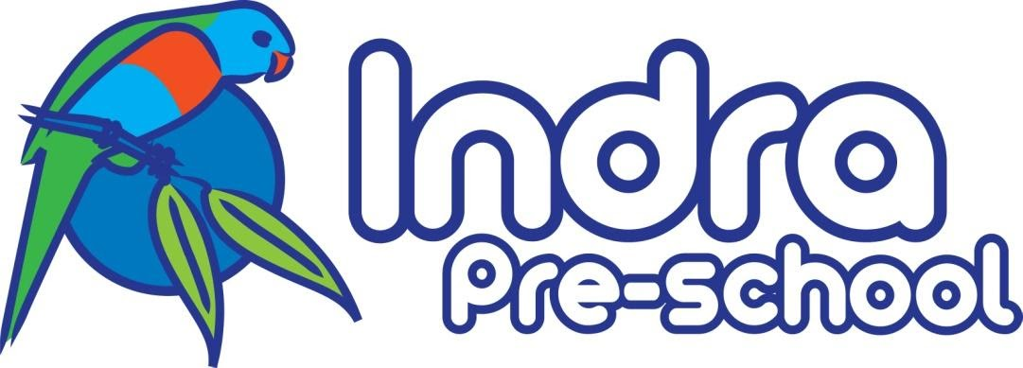

COVIDsafe Plan
Business Name: Indra Pre-School
Plan Completed by Joanna Greaves and Andrea Summers
Date Reviewed: 30th of September 2020

1. Ensure Physical Distancing
Requirements | Actions
You must ensure workers and visitors are 1.5m apart as much as possible. This can be done by:  • Displaying signs to show patron limits at the entrance of enclosed areas where limits apply  • Informing workers to work from home wherever possible  You may also consider:  • Minimising the build-up of people waiting to enter and exit the workplace  • Using floor markings to provide minimum physical distancing guides  • Reviewing delivery protocols to limit contact between delivery drivers and workers | - Display sign reminding of physical distancing and stand on crosses.  - Staggered drop off and pick up times (30-minute bracket)  - Teachers and Service Coordinator to work from home when possible.  - Limit the number of parents in the pick-up/ drop off area to a maximum of 5 people.  - Use tape to mark spaced to line up at 1.5 meters apart.  - Only essential visitors to be allowed in the building as per CHO current advice.(Attachment 1)  - No Parent Helpers
You must apply density quotient to configure shared work areas and publicly accessible spaces to ensure that:  • There is no more than one worker per four square meters of enclosed workspace  • There is no more than one member of the public per four square meters of publicly available space indoors | - Teachers and Service Coordinator to work from home when possible.  - One person in kitchen.  - Two people in office.  - Lunch table outside.  - Limit the number of parents in the pick-up/ drop off area to a maximum of 5 people.
You should provide training to workers on physical distancing expectations while working and socialising. This should include:  • Informing workers to follow current public health directions when carpooling. This can be found at vic.gov.au | - All staff to have completed infection control course.  - All staff to receive DET updates.

2. Wear a face covering
Requirements | Actions
You must ensure all workers and visitors entering the worksite wear a face covering as per public health advice. This includes:  • Providing adequate face coverings and Personal Protective Equipment (PPE) to workers that do not have their own | - All staff are required to wear a face covering except when interacting directly with the children.  - Supply of disposable masks are in office.
You should install screens or barriers in the workspace for additional protection where relevant | - Parents and visitors are to remain behind veranda gate.
You should provide training, instruction and guidance on how to correctly fit, use and dispose of PPE.  You should inform workers that cloth masks should be washed each day after use. However, if during the day the mask is visibly dirty or wet, the mask needs to be washed immediately | - Signage for staff and visitors on the correct usage of PPE.  (Attachments 2 and 3)

3. Practise good hygiene
Requirements | Actions
You must frequently and regularly clean and disinfect shared spaces, including high-touch communal items such as door knobs and telephones.  You should:  • Clean surfaces with appropriate cleaning products, including detergent and disinfectant  • Replace high-touch communal items with hygienic alternatives, for example single-use or contactless options, where possible to do so  • Clean between shifts | - Professional cleaner employed to clean every evening. Extra cleaning duties include, light switches, doorknobs, handrails, bag hooks.  - Replace communal resources, such as playdough with separate resources for each group.  - Staff to undertake additional cleaning as required.
You should display a cleaning log in shared spaces. | - Cleaning log in the kitchen, office and main room with duties as per advice from DET and the Chief Health Officer (CHO) (attachment 1) and Staying Healthy booklet file:///Users/user/Downloads/ch55-staying-healthy%20(1).pdf (attachment 6)
You should make soap and hand sanitiser available for all workers and customers throughout the worksite and encourage regular handwashing. | - We will provide:  -hand sanitizer, soap, disinfectant, alcohol wipes.

4. Keep records and act quickly if a worker becomes unwell
Requirements | Actions
You must support workers to get tested and stay home even if they only have mild symptoms. | - Send staff home if unwell and employ relief staff.  - Staff to take temperatures on arrival.  - Encourage getting tested if unwell.
You must develop a business contingency plan to manage any outbreaks. This includes:  • Having a plan to respond to a worker being notified they are a positive case while at work, noting workers who show symptoms or have been in close contact should NOT attend the workplace until they receive their test results  • Having a plan to identify and notify close contacts in the event of a positive case attending the workplace during their infectious period  • Having a plan in place to clean the worksite  (or part) in the event of a positive case  • Having a plan to contact DHHS and notify the actions taken, provide a copy of the risk assessment conducted and contact details of any close contacts  • Having a plan to immediately notify WorkSafe Victoria on 13 23 60 if you have identified a person with coronavirus  (COVID-19) at your workplace  • Having a plan in the event that you have been instructed to close by DHHS  • Having a plan to re-open your workplace once agreed by DHHS and notify workers they can return to work | - Follow advice from DET as found here:  - https://education.vic.gov.au/childhood/Pages/closure-preparedness.aspx  1. DHHS will notify the service of a confirmed case  2. Service will inform families  3. Lodge a notification through the NQAITS  4. Arrange a deep clean  5. Ensure emergency contact details are up to date with NQAITS.  (Attachment 4)
You must keep records of all people who enter the workplace for contact tracing. | Contact tracing sheet for parents and carers.  Visitor log with contact phone numbers (attachment 5)
You should implement a screening system that involves temperature checking upon entry into a workplace. | Staff and children's temperatures to be taken on arrival.

5. Avoid interactions in enclosed spaces

Requirements | Actions
You should reduce the amount of time workers are spending in enclosed spaces. This could include:  • Enabling working in outdoor environments  • Moving as much activity outside as possible, including serving customers, meetings, tearooms, lunchbreaks and locker rooms  • Enhancing airflow by opening windows and doors  • Optimising fresh air flow in air conditioning systems | - Encourage indoor /outdoor program.  - Teachers and Service coordinator to work from home when appropriate.  - Encourage outdoor lunch breaks.  - Windows open in office and main room.  - staggered drop off and pick up (30min bracket)  - Staggered mealtimes for children.  - Rather than having group times where everyone is sitting on the mat, consider using informal opportunities to engage with the children/read books/do storytelling with small groups of children at a time.  - Follow advice for CHO (Attachment 1) and Staying healthy booklet (attachment 6)

6. Create workforce bubbles
Requirements | Actions
You should keep groups of workers rostered on the same shifts at a single worksite and ensure there is no overlap of workers during shift changes. | - Any staff who work on separate days should try to avoid crossing over when practicable  - Maintain a record of staff who work across different settings
You should maintain records of all workers who have disclosed that they reside with another worker and ensure that there is no cross-over between shifts. | N/A

All attachments are editable in Indra Staff Google Drive
Attachment 1:

Health and safety advice for early childhood education and care services in the context of coronavirus (COVID-19)
The purpose of this guidance is to support early childhood services to continue to provide safe environments for children and staff where they are operating.

An update from the Victorian Chief Health Officer
As Victoria’s Chief Health Officer, and as a member of the Australian Health Protection Principal Committee, the health, wellbeing and safety of Victorian children and early childhood staff remains front of mind.
As you know, a significant change to the operation of early childhood education and care services in metropolitan Melbourne has been announced. This is not because early childhood education and care services are unsafe places for children or staff. It is to significantly reduce the movement of children and their families across metropolitan Melbourne to help slow the spread of coronavirus (COVID-19).
I want to reassure you that early childhood services operating as usual in rural and regional Victoria and providing on site education and care in metropolitan Melbourne remain safe places for staff and children when the sensible practice steps as outlined in this guidance are taken. I ask all Victorian early childhood communities to protect themselves and others by following this advice.
I am confident that risk to staff and children remains low with health and safety measures in place. With significant testing in place, I am confident in our ability to identify and respond appropriately if a child or staff member tests positive to coronavirus (COVID-19).
The vast majority of cases of coronavirus (COVID-19) observed in early childhood education and care services involve the child or staff member acquiring the virus in the community, and these cases have been well contained though reactive and temporary closures. Reassuringly, evidence also continues to show that children are less impacted by the virus, they tend to have milder symptoms and are less likely to develop severe illness.
I once again thank educators, teachers, other staff and families for their incredible efforts during these challenging times. With your support I am confident we can once again flatten the curve of the pandemic in Victoria.

Adj Clin Prof Brett Sutton
Victorian Chief Health Officer

Actions for early childhood and care settings
Early childhood settings should adopt strategies to support physical distancing and good hygiene practices to reduce the risk of coronavirus (COVID-19) transmission within the practical limitations of an early learning environment. The following actions should be implemented with adaptation as necessary according to the education setting and the individual needs of the staff, children and the wider service community.
- Display educational materials, which can be downloaded and printed from the Department of Health and Human Services (DHHS) website
- Comply with National Health and Medical Research Council (NHMRC) guidance Staying healthy: Preventing infectious diseases in early childhood education and care services
- Alert your approved provider about any large increases in child and staff absenteeism due to flu-like illnesses.
- Keep parents and staff informed of the actions you are taking.

Actions
The most important action early childhood services can take to reduce the risk of transmission of coronavirus (COVID-19) is to ensure that any unwell staff and children get tested and remain at home.
While the risk of coronavirus (COVID-19) transmission is low in early childhood services, staff or children most at risk of severe illness should continue to individually assess appropriateness for on-site attendance, with support from their medical practitioner.
As the main risk of transmission of coronavirus (COVID-19) in the early learning environment is between adults, it is important that visitors to early childhood services are controlled, and limited to those delivering or supporting essential services and operations.
- All unwell staff and children must stay home.
- Parents/carers of children with complex medical needs (including those with compromised immune systems), should seek advice from the child’s medical practitioner to support decision-making about whether on-site education and care is suitable, noting that this advice may change depending on the status of the coronavirus (COVID-19) pandemic in Victoria.
- Early childhood services should control visitor access on site and record contact details for all visitors. Visitors to early childhood services should be limited to those delivering or supporting essential services and operations.
- Visitors to early childhood services should be limited to those supporting essential service operations. Non-essential visits to services, including by parent volunteers, should be discouraged at this time.
- While it is not a requirement of entry to these settings for visitors to have been vaccinated against influenza, staff in these settings should encourage visitors to get vaccinated beforehand.
- Parent information sessions and interviews should meet physical distancing requirements of 1.5 metres between adults, or else be replaced with virtual alternatives.

Hygiene
Everyone should protect themselves and prevent the spread of coronavirus (COVID-19) by continuing to practice effective hand hygiene measures.
- All staff, children and visitors to early childhood services should undertake regular hand hygiene, particularly on arrival to the service, before and after eating, after blowing their nose, coughing, sneezing or using the toilet. You are a good role model for the children and their parents/carers, so actively talk about why everyone needs to wash their hands and the importance of everyone doing this.
- Make sure liquid soap and running water, or alcohol-based hand sanitiser, is available at the entrance of the facility and throughout.
- From 11:59pm on Sunday 2 August, a face covering will be mandatory whenever you leave home, wherever you live in Victoria. See DHHS advice on face coverings for information and guidance on use of face masks in education settings. It is not compulsory for staff to wear face coverings while teaching or caring for children as they can interfere with their ability to clearly communicate with children. While teaching or caring for children, staff can choose to wear face coverings if they wish.
- Tissues should be readily accessible with bins provided in each room and in outdoor areas for easy disposal.
- It is recommended that children do not drink directly from drinking fountains at this time. Children should bring their own water bottle for use (and refilling) at the service.
- Sharing of food should not occur.
- Ensure the highest hygiene practices amongst food handlers as per NHMRC guidance Staying healthy: Preventing infectious diseases in early childhood education and care services.
- Use of mobile phones by staff should be discouraged if possible. Staff should be reminded to clean their phones regularly.

Arrival and departure
As the main risk of introducing coronavirus (COVID-19) to the early childhood environment is from adults, close proximity between adults should be avoided, particularly during drop-off and pick-up.
- Early childhood services are strongly encouraged to conduct a temperature screen / temperature check of each child with an infrared thermometer as they arrive throughout the day, following Guidance for administering children’s temperature screening
- A single use facemask or cloth mask made to DHHS standards is recommended for staff performing temperature checks. Refer to the DHHS guidance for taking masks on and off safely. Note that a cloth mask must be washed after each use before being worn again.
- It is important to note that temperature screening does not replace the need for other important public health measures such as hand hygiene, and enhanced cleaning and disinfection.
- It is important that you consider the arrival and departure procedures for children to minimise opportunities for parents and carers to gather in groups, including in the foyer.
- If the physical layout of your service permits it and it is otherwise safe, children should be dropped off and picked up in ways that do not involve parents entering the children’s rooms and play areas.
- Staggered start and finish times should also be adopted, where possible.
- While staggered start and finish times occur naturally in some service types, early childhood education and care settings will often have one arrival and pick up time. Consider how the arrival and pick up time could be spread out. One example may be to divide the group and allocate times, noting that it is not expected that session times are extended to accommodate additional arrival and departure procedures.
- Greeting parents and children at the front door in the morning and during pick up times will allow for one-on-one communication with families while practising physical distancing and providing opportunities to consider whether children are showing any signs of being unwell.
- Encourage non-contact greetings.

Considerations for teaching and learning environments
Maintaining a physical distance of 1.5 metres will not be practical in early childhood services. Physical distancing is most important between adults.
Reducing mixing between different age or room groups is recommended as a precautionary measure to minimise risk of spread of transmission and aid containment in the rare event of a confirmed case of coronavirus (COVID-19) on-site.

- Consider small group play, staggered mealtimes and indoor/outdoor play opportunities whenever possible.
- Windows should be open during the day to promote air flow where possible.
- Consider the setup of the room and the placement of the activities and limit the number of whole group activities.
- Rather than having group times where everyone is sitting on the mat, consider using informal opportunities to engage with the children/read books/do storytelling with small groups of children at a time.
- For younger children, particularly consider the rotation of toys more often and increase the frequency of cleaning toys. Sharing of toys that have been placed in mouths should be monitored and avoided.
- Wherever possible and where you have enough staffing for adequate supervision, consider operating an indoor/outdoor program.
- A greater range of activities will encourage children and staff to spread out more broadly.
- Mixing of staff and children between rooms should be minimised where possible. It is acknowledged that staff may need to move between rooms to support breaks and, in these situations, staff should be reminded of the importance of hand hygiene.
- Where multiple staff are in a room, remind staff to maintain physical distancing from each other as much as practical.

Considerations for offices and staff facilities
As the greatest risk of transmission of coronavirus (COVID-19) in an early childhood service is between adults, close proximity between staff should be avoided, where possible, and especially in offices and staff rooms.
- Workstations should be spaced out as much as possible, and the number of staff in offices limited. Where possible, staff should use separate offices.
- In line with other workplaces across Victoria, remind staff to maintain physical distance from each other as much as possible in the reception, staff room and offices.

Cleaning and facilities management
Environmental cleaning, coupled with regular hand hygiene, remains important to reduce the risk of coronavirus (COVID-19) transmission.
- Services should maintain full adherence to the NHMRC childcare cleaning guidelines, in addition:
  - clean and disinfect high-touch surfaces at least daily (e.g. play gyms, tables, hard-backed chairs, doorknobs, light switches, remotes, handles, desks, toilets, sinks).
  - wash and launder play items and toys including washable plush toys, as appropriate, in accordance with the manufacturer’s instructions. If possible, launder items using the warmest appropriate water setting for the items and dry items completely.
  - note, disinfecting and cleaning of toys and equipment is not required after every use.
- Hand hygiene before and after use of shared equipment is recommended (for example, prior to a new activity).
- Excursions should not be undertaken other than to local parks

Provision of routine care and first aid
Physical distancing is not practical when providing direct care. In this situation, standard precautions, including hand hygiene, are important for infection control.
- Standard precautions are advised when coming in to contact with someone for the purpose of providing routine care, assistance or first aid. Also see NHMRC guidance Staying healthy: Preventing infectious diseases in early childhood education and care services.
- Always wash hands with soap and water or use a hand sanitiser before and after performing routine care or first aid.
- Additional Personal Protective Equipment (PPE), for example face masks, is not required to provide routine care or first aid for children who are well.
Management of an unwell child or staff member
It is critical that any staff member or child who becomes unwell while at an early childhood service gets tested and returns home. While it is unlikely that a staff member or child who is unwell with flu-like symptoms will have coronavirus (COVID-19), there are some sensible steps services should take while a child awaits collection by a parent or carer as a precaution.
- Staff or children experiencing compatible symptoms with coronavirus (COVID-19), such as fever, cough or sore throat, should be isolated in an appropriate space with suitable supervision and collected by a parent/carer as soon as possible. They should be encouraged to get tested and isolate at home until they receive their results. Important actions to take include hand hygiene, physical distance and where possible putting on a surgical mask (both on staff and child where appropriate).
  - Additional PPE (surgical mask, eye protection, disposable fluid repellent gown and gloves) may be considered where practicable when care is to be prolonged or a child has additional health needs.
- Face masks should not be used in situations where an individual is unable to safely or practically tolerate a mask (e.g. a child with complex medical needs, including existing respiratory needs and children under the age of 2).
- Urgent medical attention should be sought where indicated. Consider calling an ambulance.
- Health care plans, where relevant, should be updated to provide additional advice on monitoring and identification of the unwell child in the context of coronavirus (COVID-19).
- If a staff member is unsure whether a child is unwell, it is advisable in the first instance to contact the parent/carer to discuss any concerns about the health status of the child and, taking a precautionary approach, request the parent/carer to collect their child if concerns remain. A trained staff member could take the temperature of the child, where appropriate, to support decision making, ensuring hand hygiene is performed before and after.
- Staff or children experiencing symptoms compatible with coronavirus (COVID-19) should be encouraged to get tested and isolate at home until they receive their test result. A medical certificate is not required to return to an early childhood setting after a period of illness. However, once tested, staff and children must not return until they have received their test result and their symptoms resolve.
- Follow cleaning guidance according to the situation of the case. If a child spreads droplets (for example by sneezing, coughing or vomiting), clean surfaces immediately with disinfectant wipes while wearing gloves.

Attachment 2:

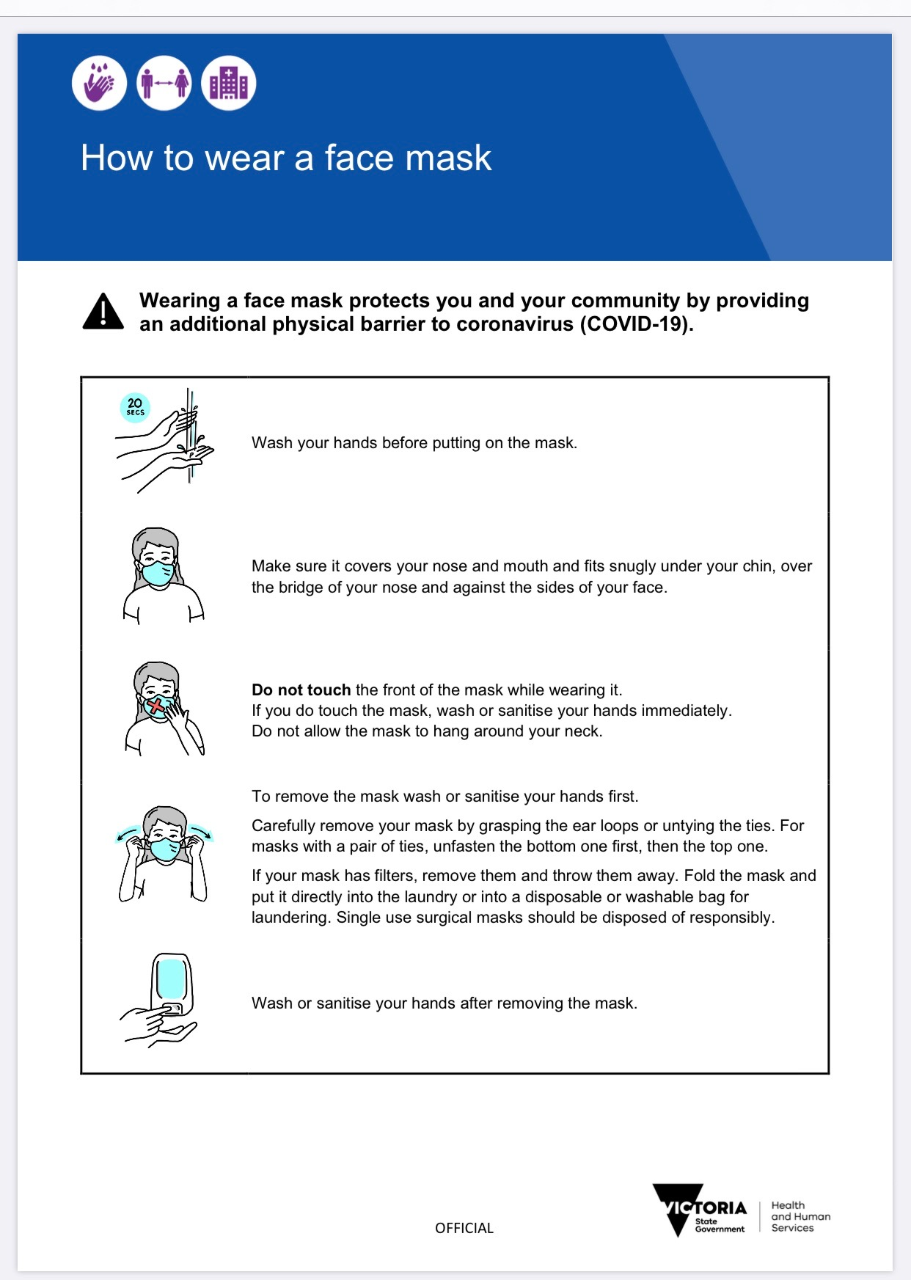

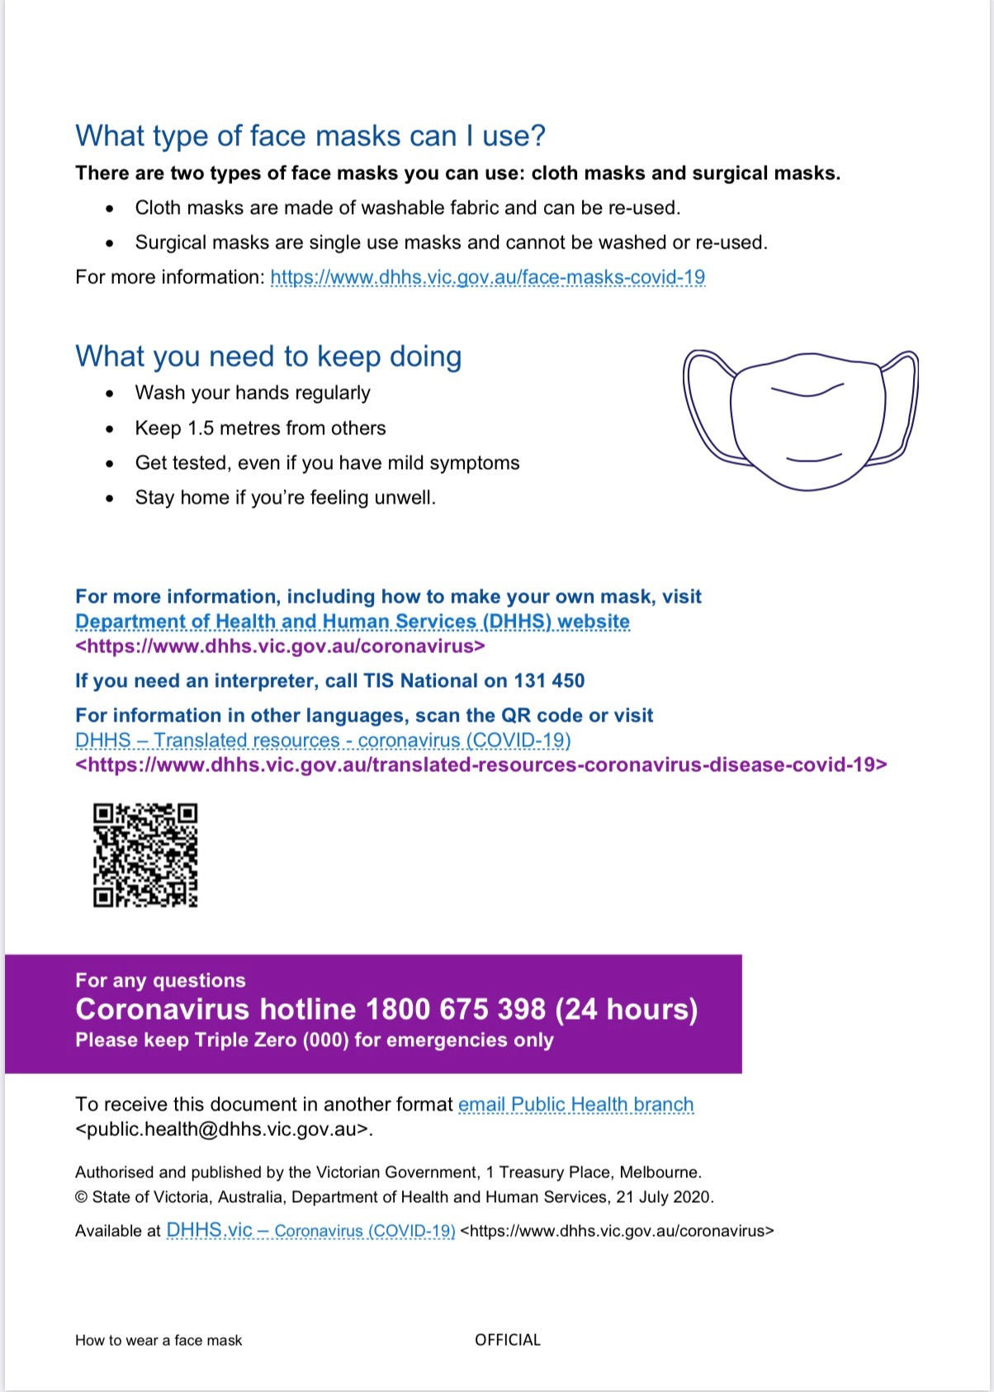

Attachment 3:
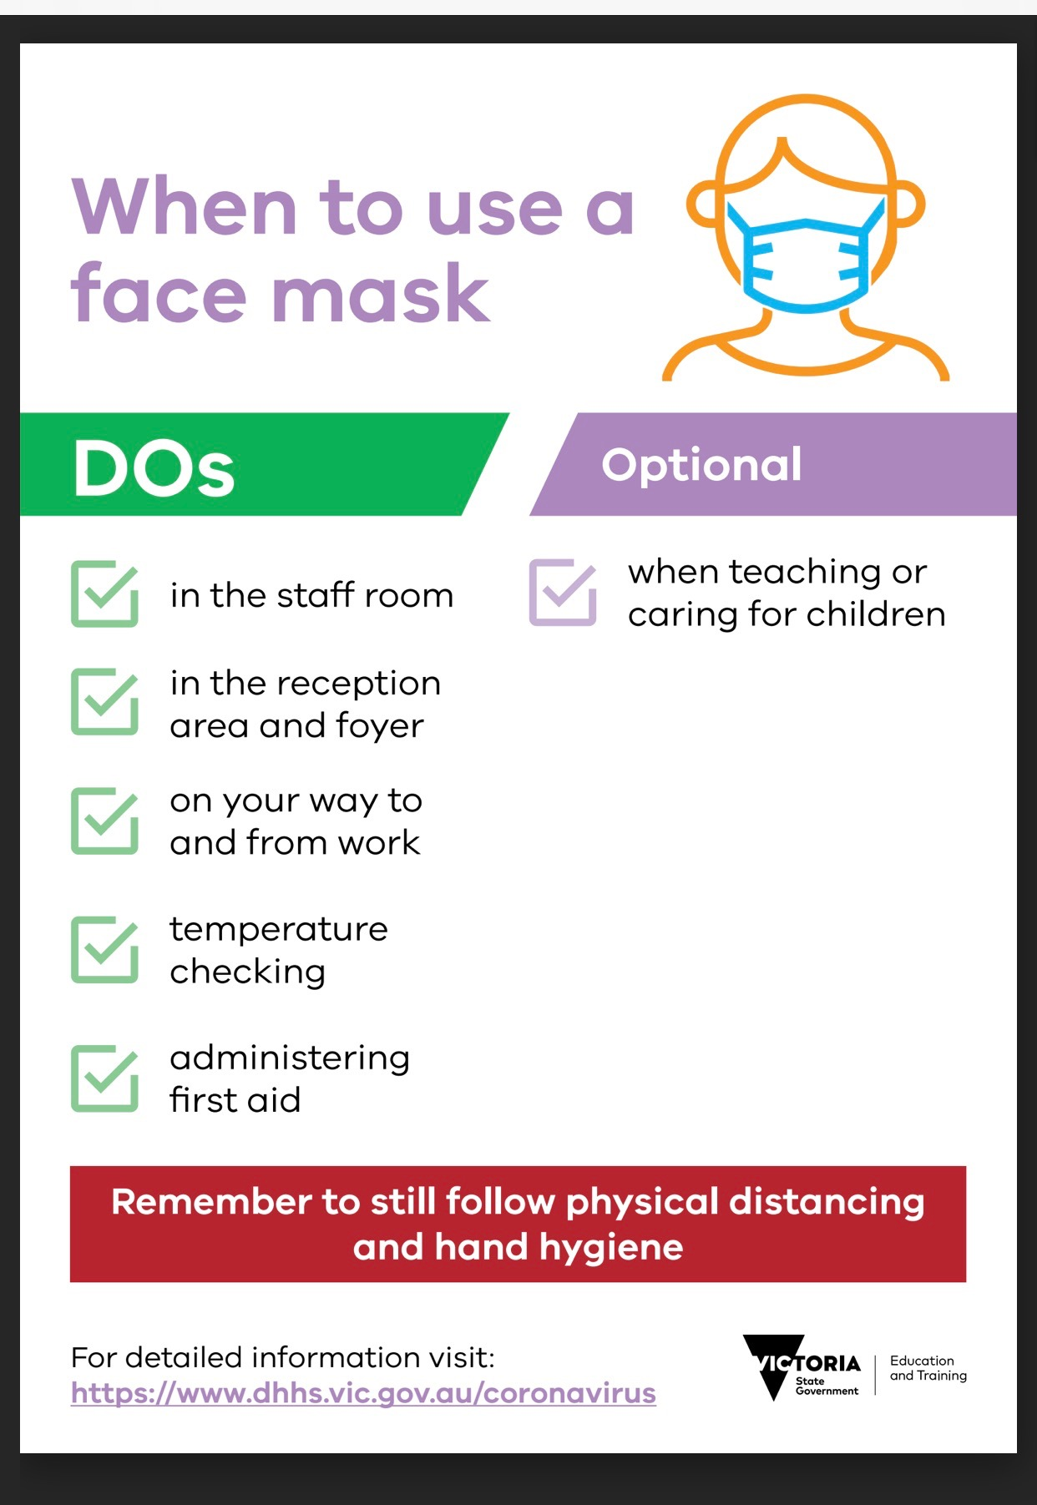
Attachment 4:
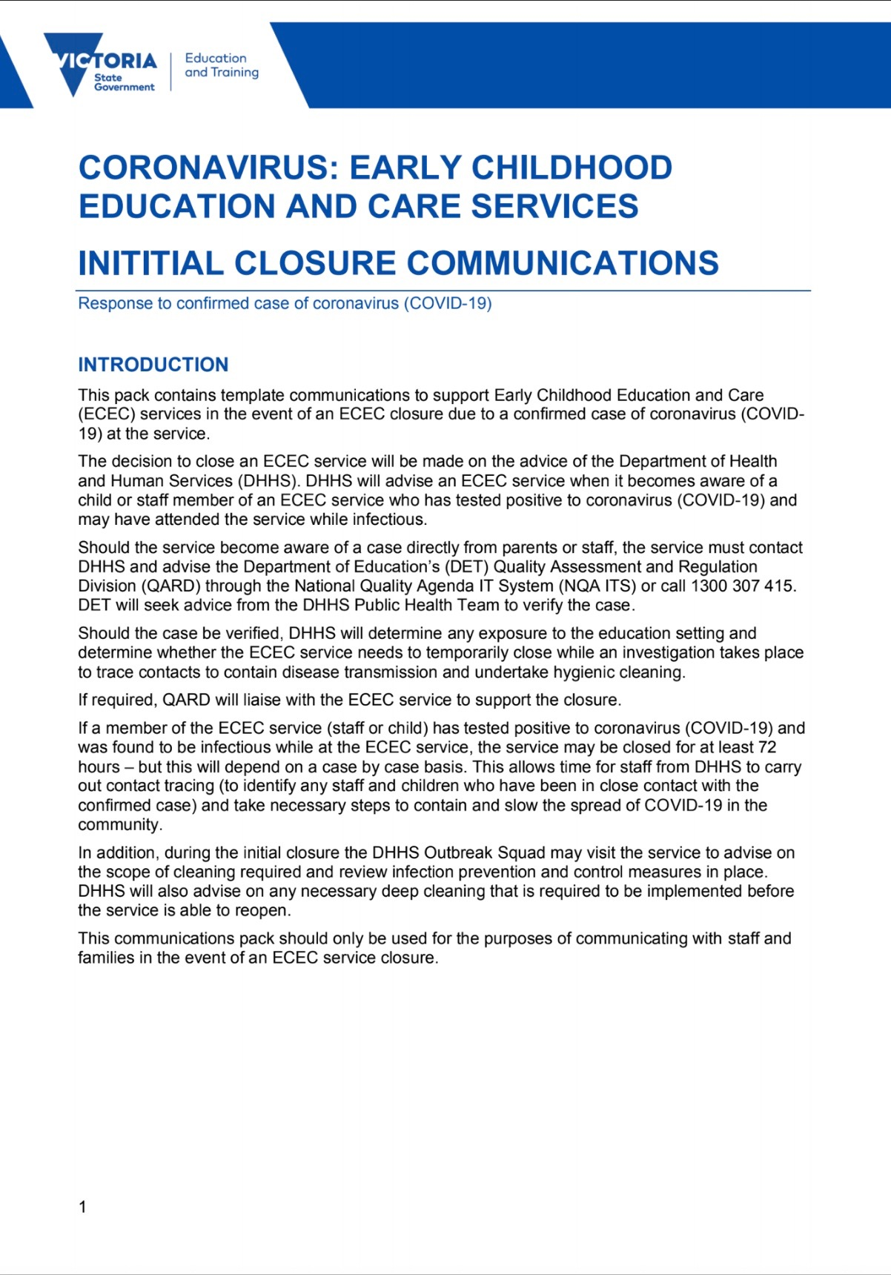
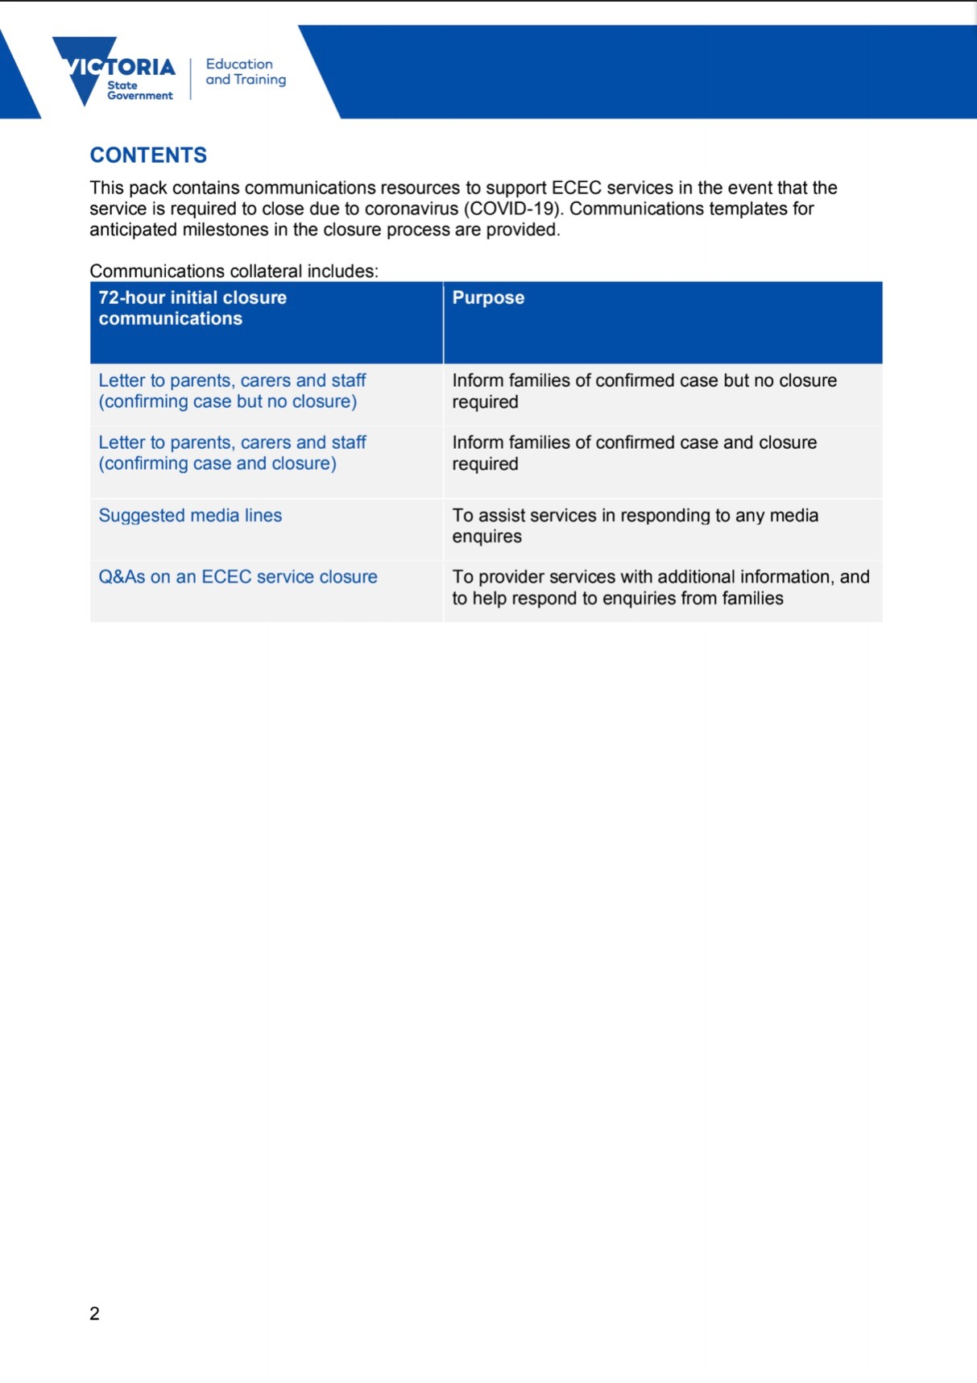

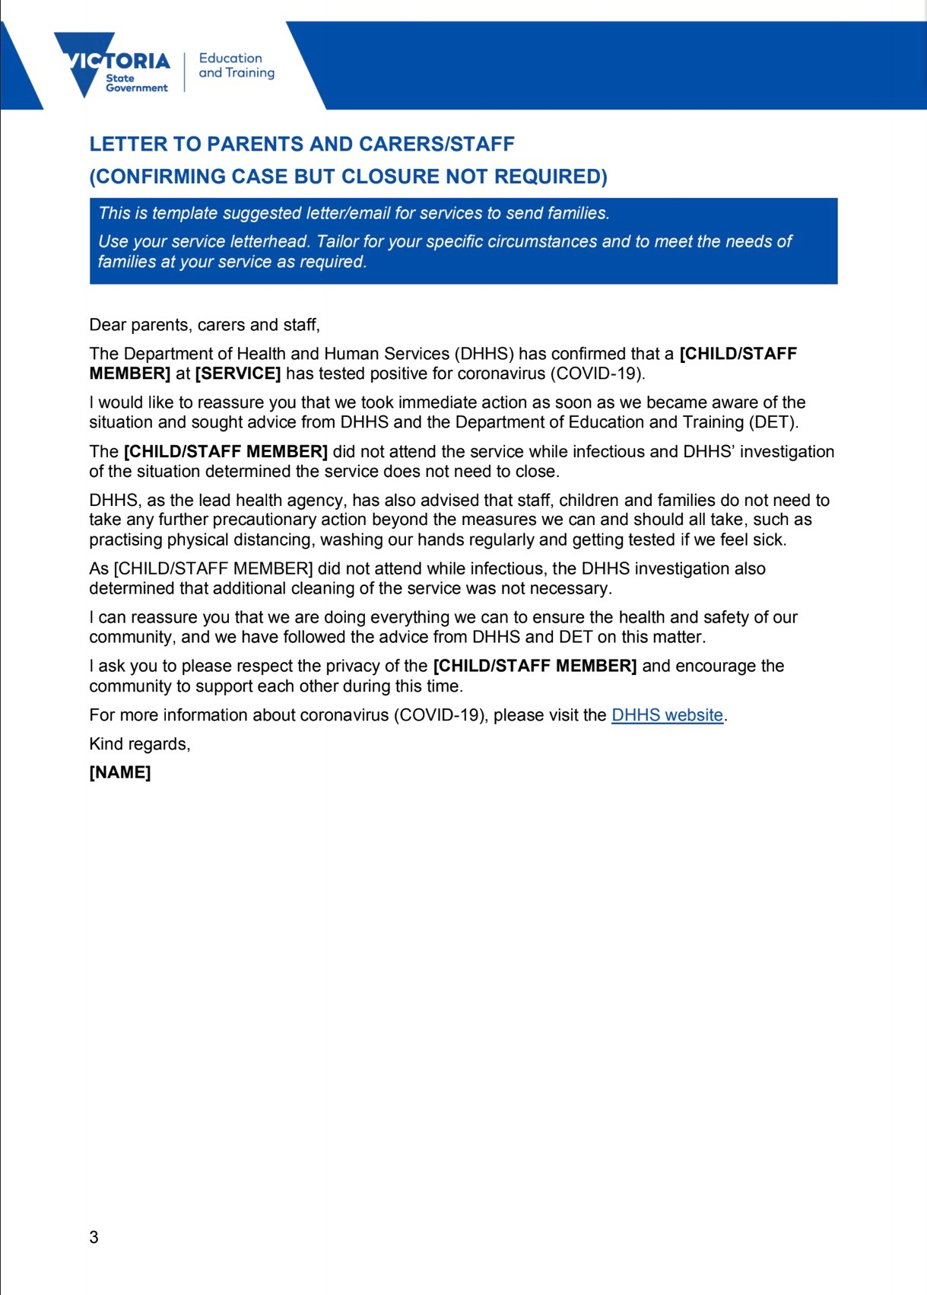

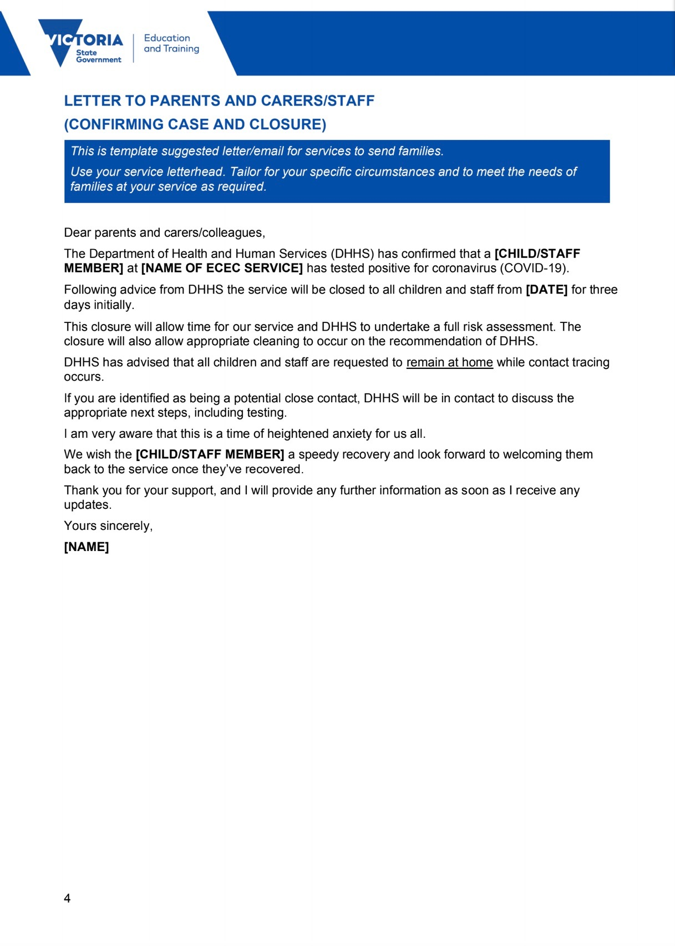
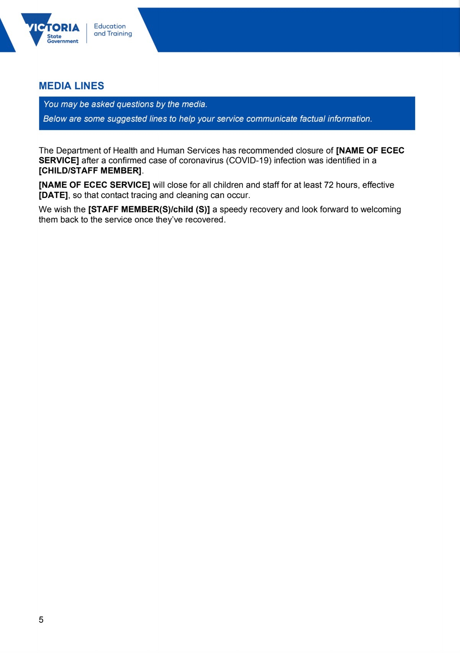

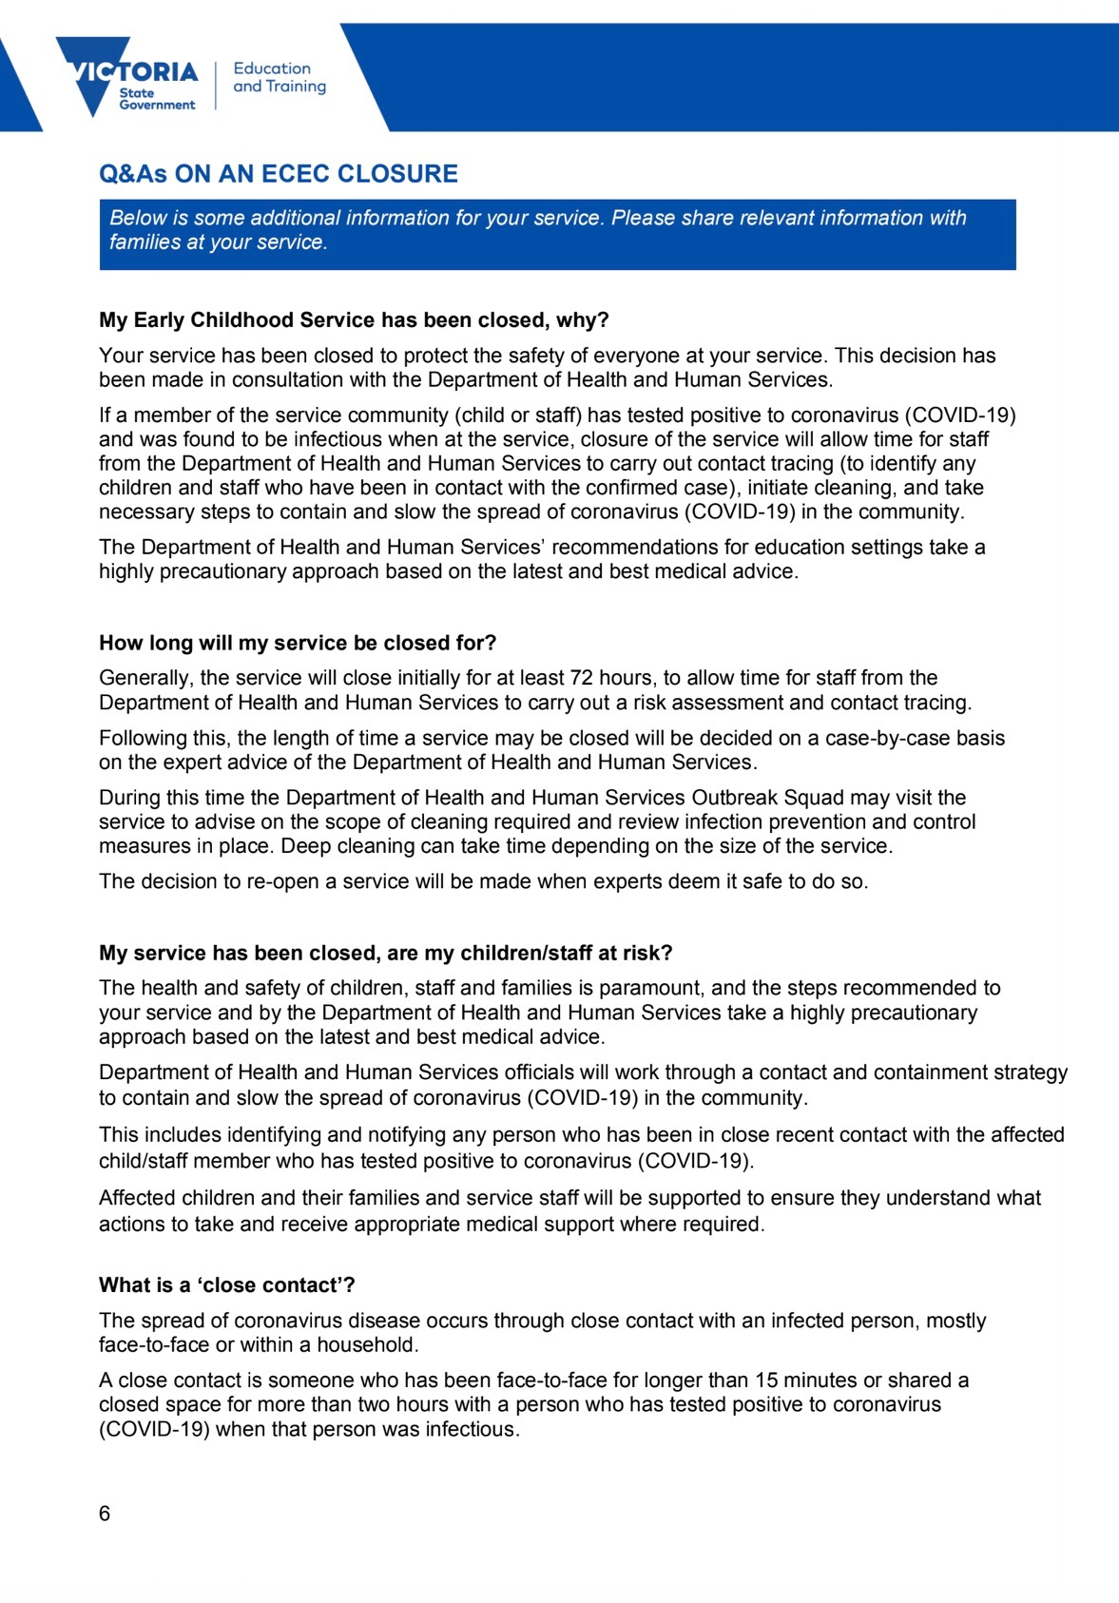

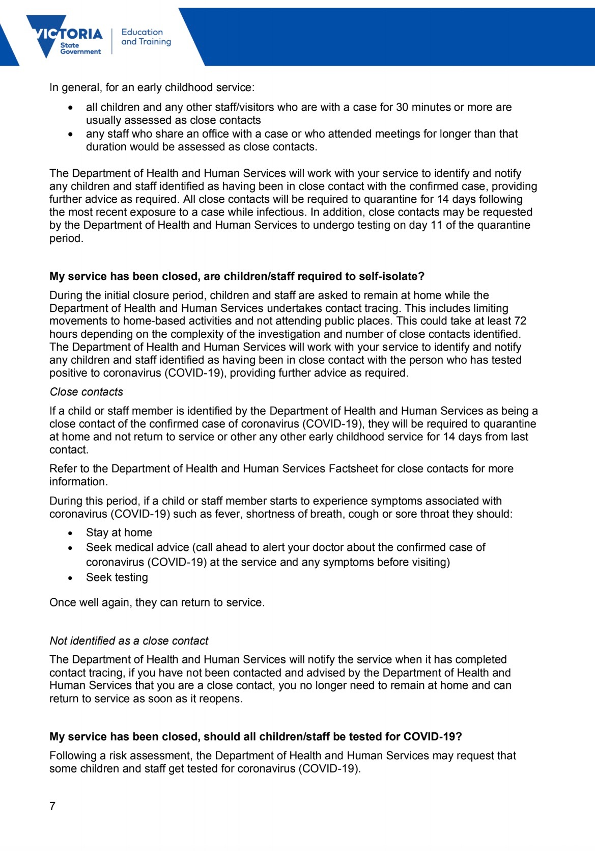

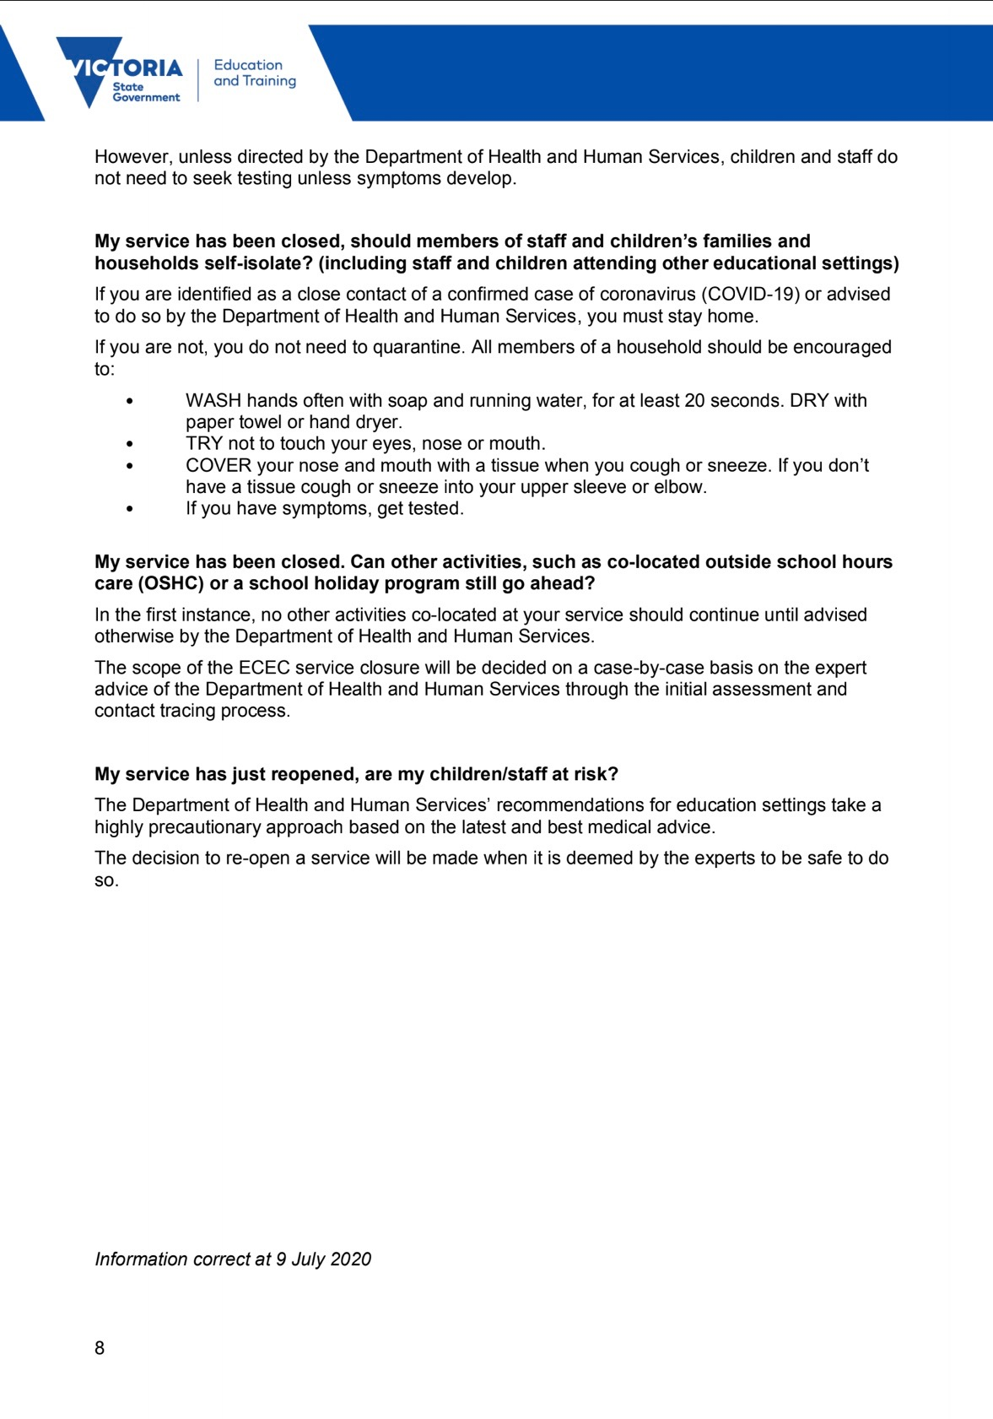

Attachment 5: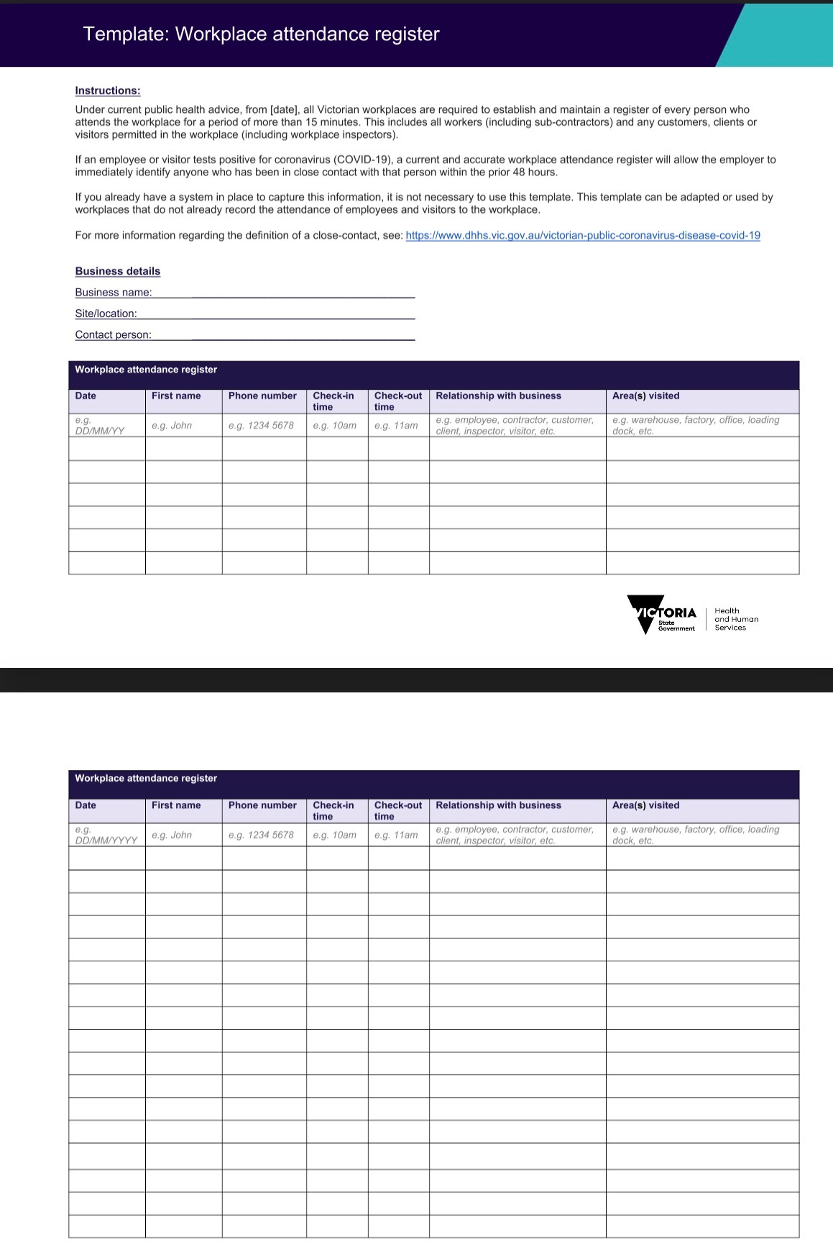
Attachment 6:
Full version of the Staying Healthy guide is available here: file:///Users/user/Downloads/ch55-staying-healthy%20(1).pdf